Bash Scripting tasks
1) Create on Bash script to check if a directory is available or not.
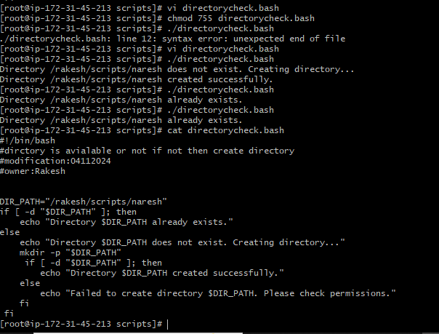
2) Create a bash script which will create multiple files.
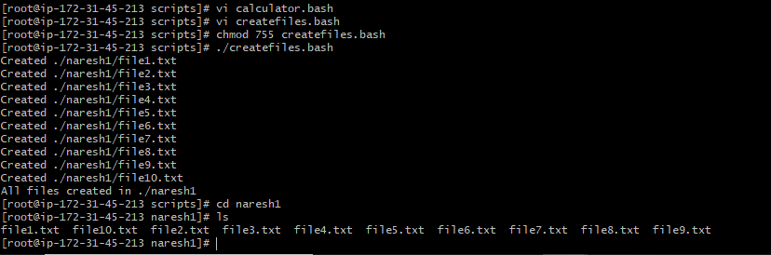
3) Create a bash script to take backup of a directory.
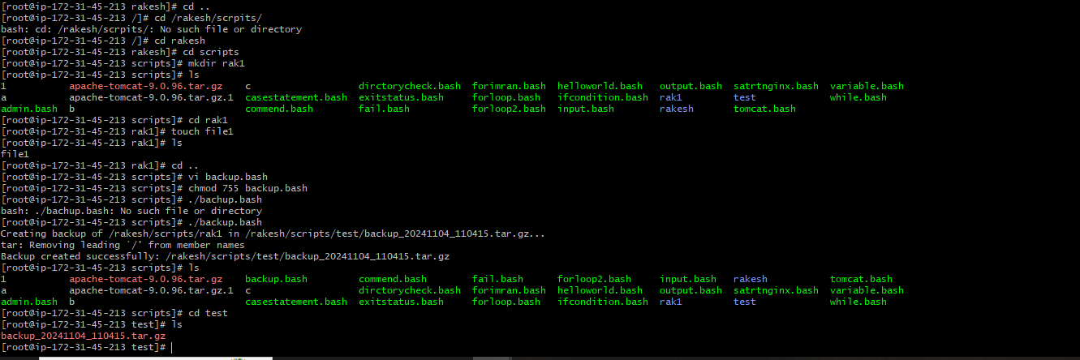

4) Create a bash script to install nginx in ec2 server.
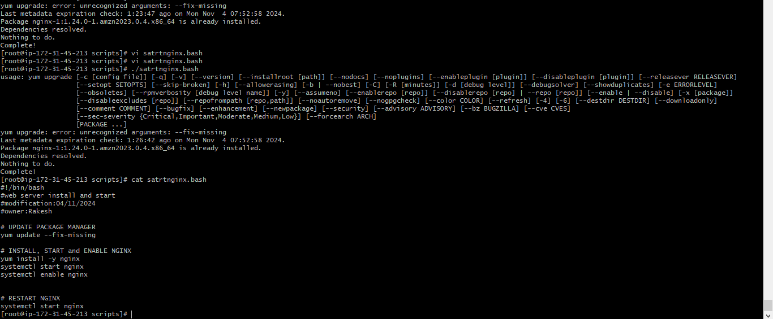
5) Create a bash script to install ApacheTomcat in ec2 server.
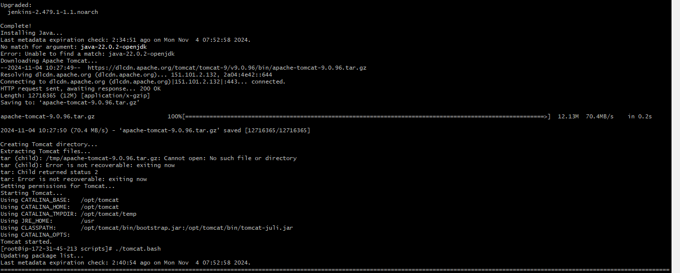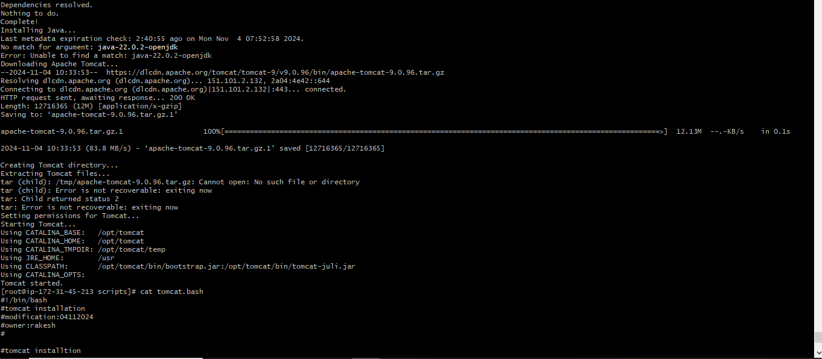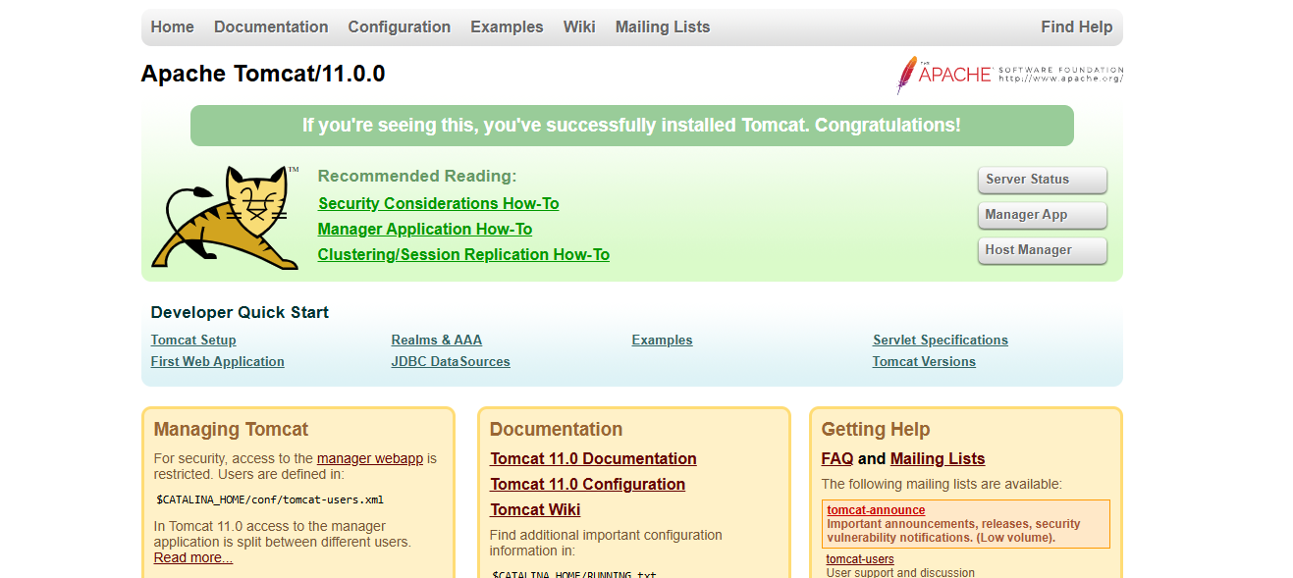
6) Create a bash script to check list if nginx service is running or not,if not running then script should start the service.
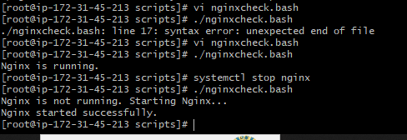
7) Create a bash script for calculator.
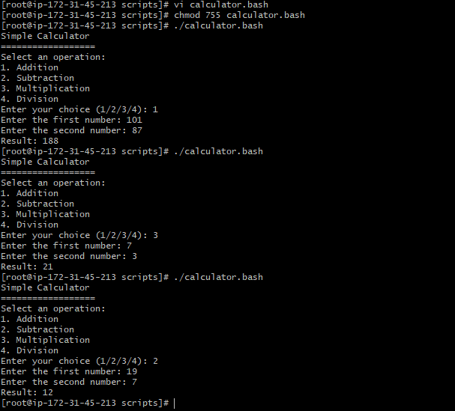
8) Create a bash script to check if directory is avaialble or not,if not then create a directory.

9) Create bash script to delete last 3 lines for a file.
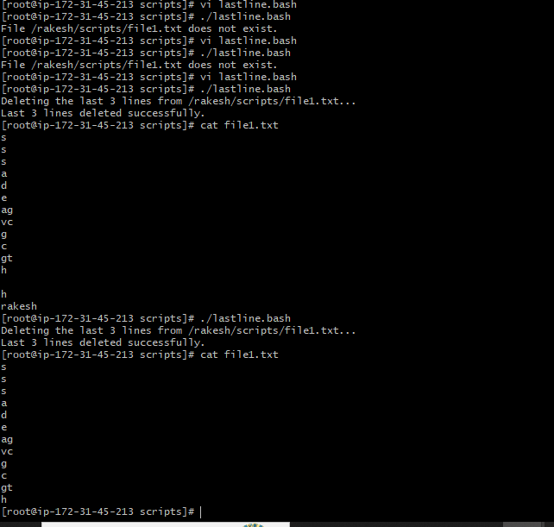
Crontab tasks
1) April 5th Midnight
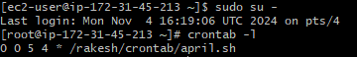
2) 5 th of Every November,Jan,June if it is a Thursday.
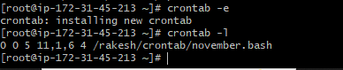
3) At 05 and 27th minutes of 9,10,11 hours everyday.
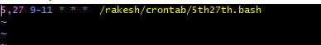
4) 34 min. of 9th hour on 15th Aug.
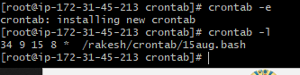
5) Every midnight
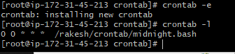
6) Every Weekend ( Saturday night 11.59 )
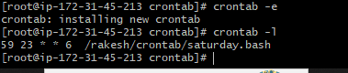
7) After every reboot
